**ANALYZATION OF NFT DATA**

The procedures below involve using sql inorder to analyze the data and google sheet for the histogram, phpMyAdim was for mysql.

**1)Count the total number of NFT sales in the dataset:**

**Sql Code:**

SELECT COUNT(*) AS total_sales FROM pricedata;

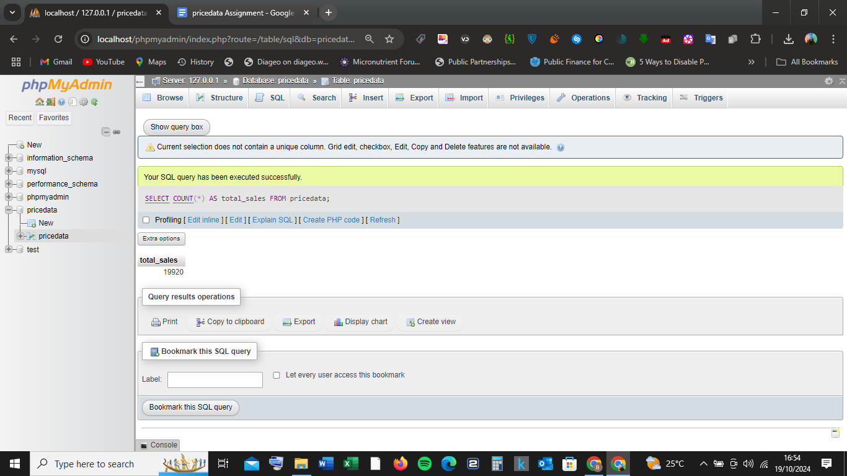

**Output:**

| **total_sales** |  |
| --- | --- |
| **19920** |  |

**2)Identify the top 5 most expensive transactions by USD price (name, ETH price, USD price, date):**

**Sql code:**

SELECT name, eth_price, usd_price, event_date

FROM pricedata

ORDER BY usd_price DESC

LIMIT 5;

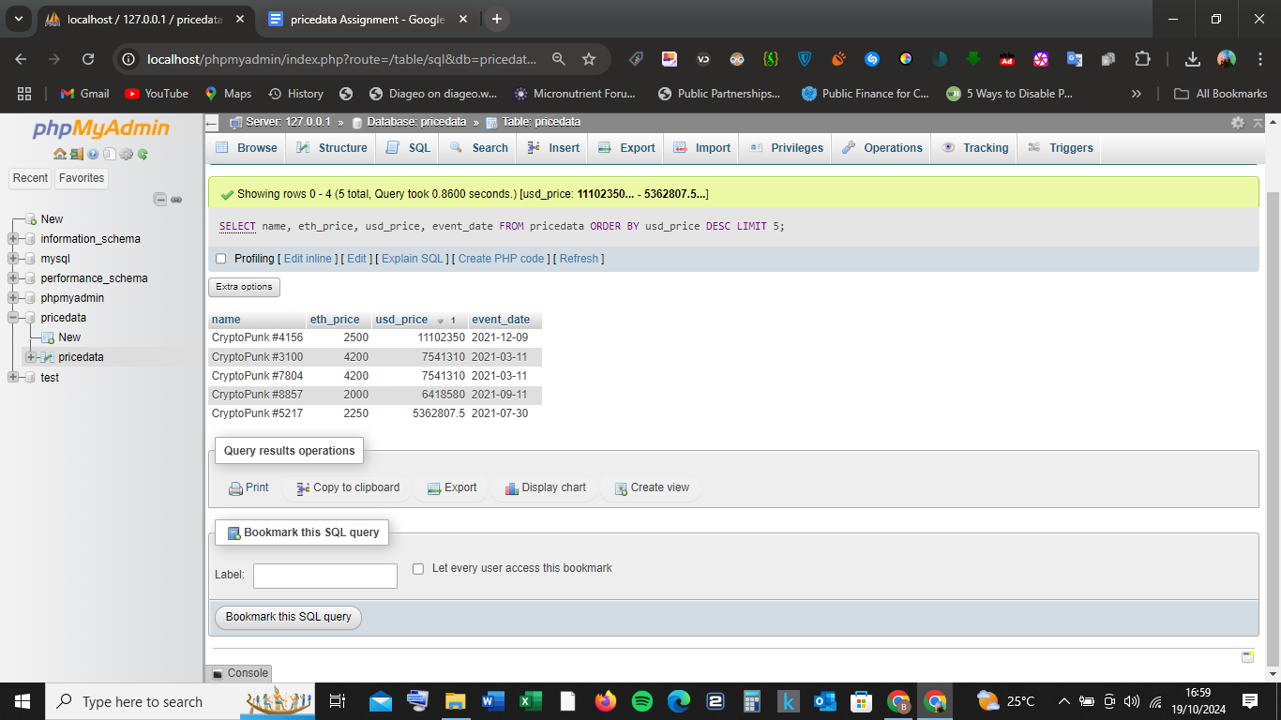

**Output**

| [**name**](http://localhost/phpmyadmin/index.php?route=/sql&db=pricedata&table=pricedata&sql_query=SELECT+name%2C+eth_price%2C+usd_price%2C+event_date%0D%0AFROM+pricedata+%0AORDER+BY+%60pricedata%60.%60name%60+ASC+LIMIT+5&sql_signature=fdc413f1c523fae120b691e6780f59c004861a8446d6887fcc7931c1b6e46a9d&session_max_rows=25&is_browse_distinct=0) | [**eth_price**](http://localhost/phpmyadmin/index.php?route=/sql&db=pricedata&table=pricedata&sql_query=SELECT+name%2C+eth_price%2C+usd_price%2C+event_date%0D%0AFROM+pricedata+%0AORDER+BY+%60pricedata%60.%60eth_price%60+ASC+LIMIT+5&sql_signature=fae1d958307fda455352ecb8aa04695db4e8bfdccdf6639c13d169a842810883&session_max_rows=25&is_browse_distinct=0) | [**usd_price Descending 1**](http://localhost/phpmyadmin/index.php?route=/sql&db=pricedata&table=pricedata&sql_query=SELECT+name%2C+eth_price%2C+usd_price%2C+event_date%0D%0AFROM+pricedata+%0AORDER+BY+%60pricedata%60.%60usd_price%60+ASC+LIMIT+5&sql_signature=9870254d1e73edc1dd1357e79555f3070b7391d5a13af48b6131b3c3161b5838&session_max_rows=25&is_browse_distinct=0) | [**event_date**](http://localhost/phpmyadmin/index.php?route=/sql&db=pricedata&table=pricedata&sql_query=SELECT+name%2C+eth_price%2C+usd_price%2C+event_date%0D%0AFROM+pricedata+%0AORDER+BY+%60pricedata%60.%60event_date%60+ASC+LIMIT+5&sql_signature=13a14cec0280395221c5016b4448bd603ca8f80a1df842e1d918c3ada55fb821&session_max_rows=25&is_browse_distinct=0) |  |
| --- | --- | --- | --- | --- |
| **CryptoPunk #4156** | **2500** | **11102350** | **2021-12-09** |  |
| **CryptoPunk #3100** | **4200** | **7541310** | **2021-03-11** |  |
| **CryptoPunk #7804** | **4200** | **7541310** | **2021-03-11** |  |
| **CryptoPunk #8857** | **2000** | **6418580** | **2021-09-11** |  |
| **CryptoPunk #5217** | **2250** | **5362807.5** | **2021-07-30** |  |

**Query results operations**

**3)Create a table that includes a moving average of the USD price for the last 50 transactions:**

MySQL doesn’t have a built-in moving average function, but i calculated it using a subquery:

**Sql code:**

SELECT t1.transaction_hash, t1.usd_price, (

SELECT AVG(t2.usd_price)

FROM pricedata t2

WHERE t2.transaction_hash <= t1.transaction_hash

ORDER BY t2.transaction_hash DESC

LIMIT 50

) AS moving_avg

FROM pricedata t1

ORDER BY t1.transaction_hash;

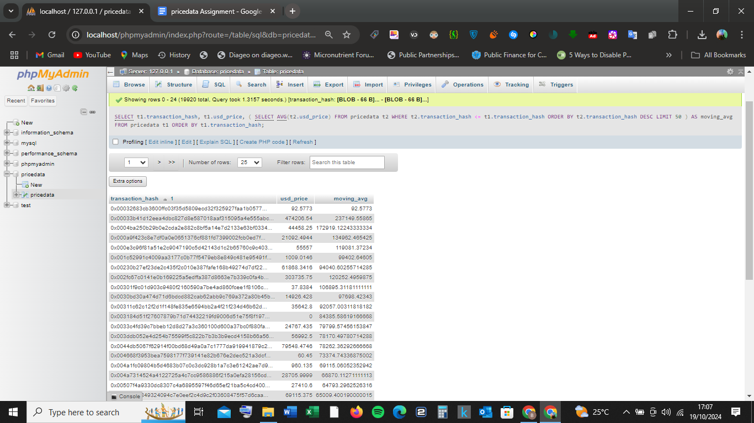

**Output(Afew):**

| [**transaction_hash Ascending 1**](http://localhost/phpmyadmin/index.php?route=/sql&db=pricedata&table=pricedata&sql_query=SELECT+t1.transaction_hash%2C+t1.usd_price%2C+%28%0D%0A++++SELECT+AVG%28t2.usd_price%29%0D%0A++++FROM+pricedata+t2%0D%0A++++WHERE+t2.transaction_hash+%3C%3D+t1.transaction_hash%0D%0A++++ORDER+BY+t2.transaction_hash+DESC%0D%0A+++%0AORDER+BY+%60t1%60.%60transaction_hash%60+DESC+LIMIT+50%0D%0A%29+AS+moving_avg%0D%0AFROM+pricedata+t1++&sql_signature=86dabfa1ea85f2f83fa0985310bdd65a3bc84ee273aaf94f00c37d1cda40cd58&session_max_rows=25&is_browse_distinct=0) | [**usd_price**](http://localhost/phpmyadmin/index.php?route=/sql&db=pricedata&table=pricedata&sql_query=SELECT+t1.transaction_hash%2C+t1.usd_price%2C+%28%0D%0A++++SELECT+AVG%28t2.usd_price%29%0D%0A++++FROM+pricedata+t2%0D%0A++++WHERE+t2.transaction_hash+%3C%3D+t1.transaction_hash%0D%0A++++ORDER+BY+t2.transaction_hash+DESC%0D%0A+++%0AORDER+BY+%60t1%60.%60usd_price%60+ASC+LIMIT+50%0D%0A%29+AS+moving_avg%0D%0AFROM+pricedata+t1++&sql_signature=0c249b04bb0aaa707fbb5572de14ccb480850204b4ef2df545185089f1742ffb&session_max_rows=25&is_browse_distinct=0) | [**moving_avg**](http://localhost/phpmyadmin/index.php?route=/sql&db=pricedata&table=pricedata&sql_query=SELECT+t1.transaction_hash%2C+t1.usd_price%2C+%28%0D%0A++++SELECT+AVG%28t2.usd_price%29%0D%0A++++FROM+pricedata+t2%0D%0A++++WHERE+t2.transaction_hash+%3C%3D+t1.transaction_hash%0D%0A++++ORDER+BY+t2.transaction_hash+DESC%0D%0A+++%0AORDER+BY+%60moving_avg%60+ASC+LIMIT+50%0D%0A%29+AS+moving_avg%0D%0AFROM+pricedata+t1++&sql_signature=7e06e6bb1e1f5f61738f754a7c4f3ab83ee080f3a1aa891fddc7f455d99f02cf&session_max_rows=25&is_browse_distinct=0) |  |
| --- | --- | --- | --- |
| 0x00032683cb3600ffc03f35d5809ecd32f325927faa1b0577... | 92.5773 | 92.5773 |  |
| 0x00033b41d12eea4dbc827d8e587018aaf315095a4e555abc... | 474206.54 | 237149.55865 |  |
| 0x0004ba250b29b0e2cda2e882c8bf5a14e7d2133e63bf0334... | 44458.25 | 172919.12243333334 |  |
| 0x000a9f423c8e7df0a0e0651376cf881fd7399002fcb0ed7f... | 21092.4944 | 134962.465425 |  |
| 0x000e3c96f81a51e2c9047190c5d42143d1c2b65760c9c403... | 55557 | 119081.37234 |  |
| 0x001c52991c4009aa3177c0b77f5479eb8e849c481e95491f... | 1009.0146 | 99402.64605 |  |
| 0x00230b27ef23de2c435f2c010e387fafe168b49274d7df22... | 61868.3416 | 94040.60255714285 |  |
| 0x002fc67c0141e0b169225a5edffa387d8663e7b339c0fa4b... | 303735.75 | 120252.4959875 |  |
| 0x00301f9c01d903c9480f2160590a7be4ad860fcee1f8106c... | 37.8384 | 106895.31181111111 |  |
| 0x0030bd30a474d71d6bdcd882cab62abb9c769a372a80b45b... | 14926.428 | 97698.42343 |  |
| 0x00311c62c12f2d1f148fe835e6594bb2a4f21f234d46b62d... | 35642.8 | 92057.00311818182 |  |
| 0x003184d51f27607879b71d74432219fd9006d51e75f8f197... | 0 | 84385.58619166668 |  |
| 0x0033c4fd39c7bbeb12d8d27a3c360100d600a37bc0f880fa... | 24767.435 | 79799.57456153847 |  |
| 0x003ddb052e4d254b75599f5c822b7b3b3b9ecd4158b66a56... | 56992.5 | 78170.49780714288 |  |

**4) Return a list of all NFT names and their average sale price, sorted in descending order:**

**Sql code:**

SELECT name, AVG(usd_price) AS avg_price

FROM pricedata

GROUP BY name

ORDER BY avg_price DESC;

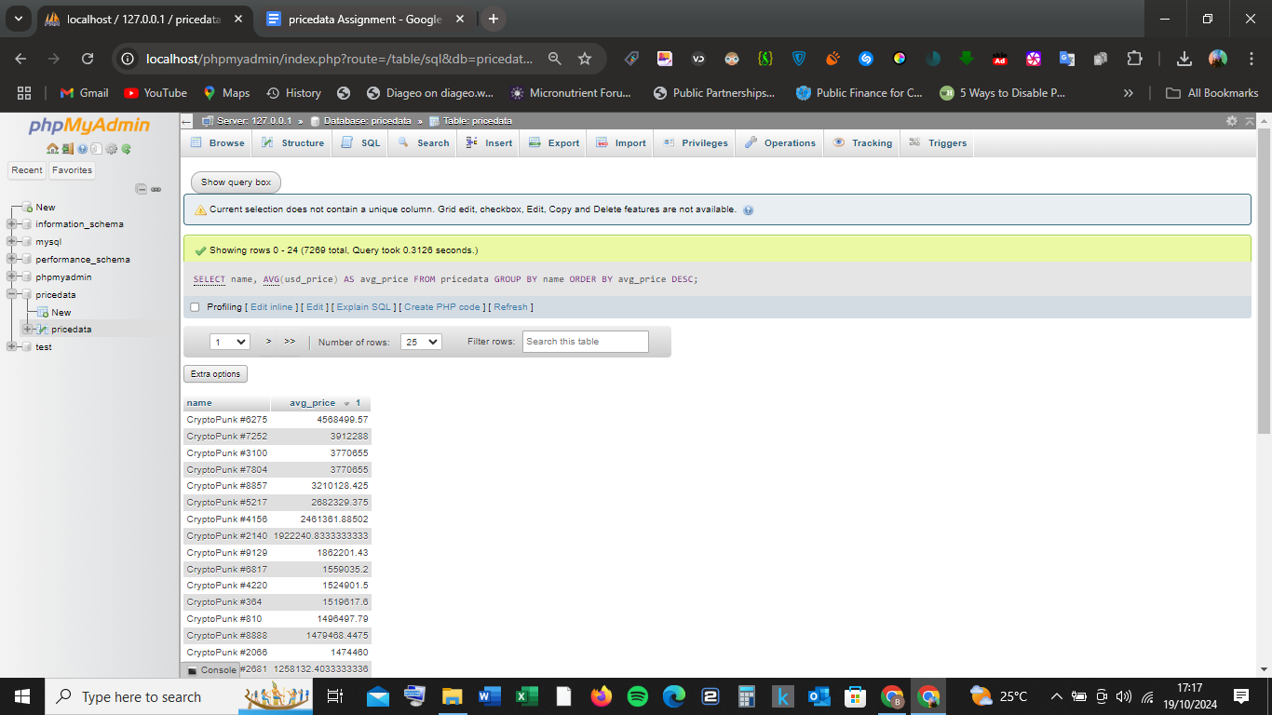

**Output(A few):**

| [**name**](http://localhost/phpmyadmin/index.php?route=/sql&db=pricedata&table=pricedata&sql_query=SELECT+name%2C+AVG%28usd_price%29+AS+avg_price%0D%0AFROM+pricedata%0D%0AGROUP+BY+name++%0AORDER+BY+%60pricedata%60.%60name%60+ASC&sql_signature=22ec72f435efebb06ee5ad00b5b9b10706ec10375fa415cca0ff66b3bc0f43ae&session_max_rows=25&is_browse_distinct=0) | [**avg_price Descending 1**](http://localhost/phpmyadmin/index.php?route=/sql&db=pricedata&table=pricedata&sql_query=SELECT+name%2C+AVG%28usd_price%29+AS+avg_price%0D%0AFROM+pricedata%0D%0AGROUP+BY+name++%0AORDER+BY+%60avg_price%60+ASC&sql_signature=fc620be985ec718b54f79e0700764bce0b58337885e1cb074bcee57fe706a01d&session_max_rows=25&is_browse_distinct=0) |  |
| --- | --- | --- |
| **CryptoPunk #6275** | **4568499.57** |  |
| **CryptoPunk #7252** | **3912288** |  |
| **CryptoPunk #3100** | **3770655** |  |
| **CryptoPunk #7804** | **3770655** |  |
| **CryptoPunk #8857** | **3210128.425** |  |
| **CryptoPunk #5217** | **2682329.375** |  |
| **CryptoPunk #4156** | **2461361.88502** |  |
| **CryptoPunk #2140** | **1922240.8333333333** |  |

**5)Provide a breakdown of sales by day of the week and the average ETH price per day:**

**Sql code:**

SELECT DAYNAME(event_date) AS day_of_week, AVG(eth_price) AS avg_eth_price

FROM pricedata

GROUP BY day_of_week

ORDER BY FIELD(day_of_week, 'Monday', 'Tuesday', 'Wednesday', 'Thursday', 'Friday', 'Saturday', 'Sunday');

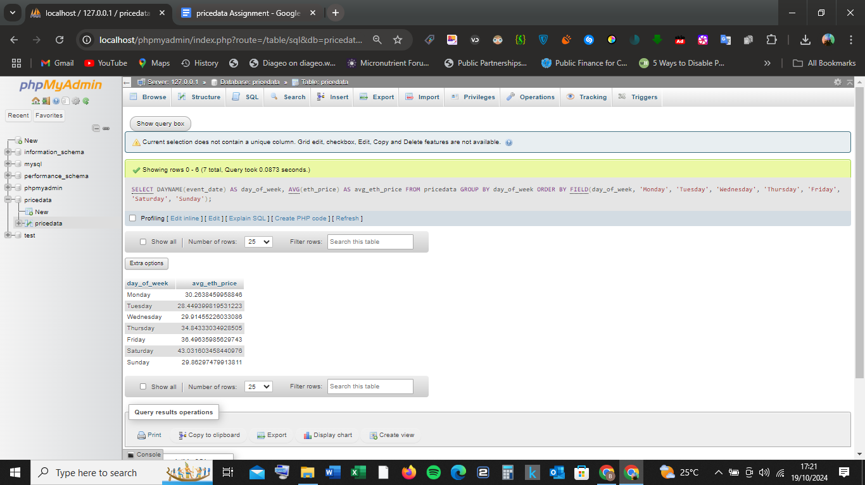

**Output:**

| [**day_of_week**](http://localhost/phpmyadmin/index.php?route=/sql&db=pricedata&table=pricedata&sql_query=SELECT+DAYNAME%28event_date%29+AS+day_of_week%2C+AVG%28eth_price%29+AS+avg_eth_price%0D%0AFROM+pricedata%0D%0AGROUP+BY+day_of_week++%0AORDER+BY+%60day_of_week%60+ASC&sql_signature=d024d1d9ad48b6c644fb6e5e27ffdb04d18add169f6f3120ddb84363000e3da6&session_max_rows=25&is_browse_distinct=0) | [**avg_eth_price**](http://localhost/phpmyadmin/index.php?route=/sql&db=pricedata&table=pricedata&sql_query=SELECT+DAYNAME%28event_date%29+AS+day_of_week%2C+AVG%28eth_price%29+AS+avg_eth_price%0D%0AFROM+pricedata%0D%0AGROUP+BY+day_of_week++%0AORDER+BY+%60avg_eth_price%60+ASC&sql_signature=b5c3ba0d6ee9ad531475d4fba4faeb03d783887a5d1d1d7937de4fb91098533b&session_max_rows=25&is_browse_distinct=0) |  |
| --- | --- | --- |
| **Monday** | **30.2638459958846** |  |
| **Tuesday** | **28.449399819531223** |  |
| **Wednesday** | **29.91455226033086** |  |
| **Thursday** | **34.84333034928505** |  |
| **Friday** | **36.49635985629743** |  |
| **Saturday** | **43.031603458440976** |  |
| **Sunday** | **29.86297479913811** |  |

**6)Construct a "summary" column for each transaction (buyer, seller, NFT name, sale price):**

**Sql Code:**

SELECT

buyer_address,

seller_address,

name,

usd_price,

CONCAT('Buyer: ', buyer_address, ', Seller: ', seller_address, ', NFT: ', name, ', Sale Price: $', usd_price) AS summary

FROM pricedata;

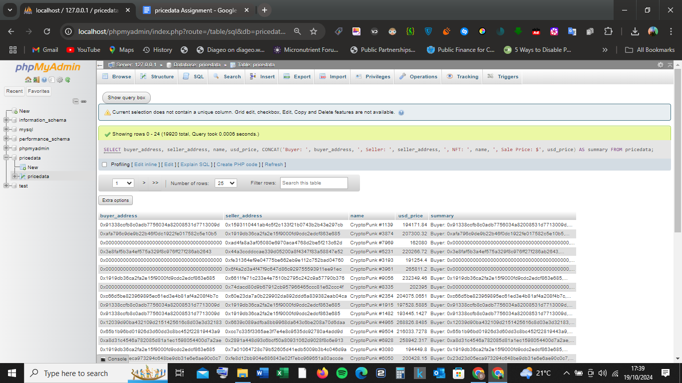

**Output:**

| [**buyer_address**](http://localhost/phpmyadmin/index.php?route=/sql&db=pricedata&table=pricedata&sql_query=SELECT+%0D%0A++++buyer_address%2C+%0D%0A++++seller_address%2C+%0D%0A++++name%2C+%0D%0A++++usd_price%2C+%0D%0A++++CONCAT%28%27Buyer%3A+%27%2C+buyer_address%2C+%27%2C+Seller%3A+%27%2C+seller_address%2C+%27%2C+NFT%3A+%27%2C+name%2C+%27%2C+Sale+Price%3A+%24%27%2C+usd_price%29+AS+summary%0D%0AFROM+pricedata++%0AORDER+BY+%60pricedata%60.%60buyer_address%60+ASC&sql_signature=8a0fdca50cefa9963d005908703d69da621453d96bccdad2cfc05ca447f93a44&session_max_rows=25&is_browse_distinct=0) | [**seller_address**](http://localhost/phpmyadmin/index.php?route=/sql&db=pricedata&table=pricedata&sql_query=SELECT+%0D%0A++++buyer_address%2C+%0D%0A++++seller_address%2C+%0D%0A++++name%2C+%0D%0A++++usd_price%2C+%0D%0A++++CONCAT%28%27Buyer%3A+%27%2C+buyer_address%2C+%27%2C+Seller%3A+%27%2C+seller_address%2C+%27%2C+NFT%3A+%27%2C+name%2C+%27%2C+Sale+Price%3A+%24%27%2C+usd_price%29+AS+summary%0D%0AFROM+pricedata++%0AORDER+BY+%60pricedata%60.%60seller_address%60+ASC&sql_signature=a7e32359465b9dbbb1a4f6b4213f73258b65c4ca9180c78ae3fecbc4667fc79c&session_max_rows=25&is_browse_distinct=0) | [**name**](http://localhost/phpmyadmin/index.php?route=/sql&db=pricedata&table=pricedata&sql_query=SELECT+%0D%0A++++buyer_address%2C+%0D%0A++++seller_address%2C+%0D%0A++++name%2C+%0D%0A++++usd_price%2C+%0D%0A++++CONCAT%28%27Buyer%3A+%27%2C+buyer_address%2C+%27%2C+Seller%3A+%27%2C+seller_address%2C+%27%2C+NFT%3A+%27%2C+name%2C+%27%2C+Sale+Price%3A+%24%27%2C+usd_price%29+AS+summary%0D%0AFROM+pricedata++%0AORDER+BY+%60pricedata%60.%60name%60+ASC&sql_signature=b1e2c7691634e91f056403905aad47a0c30dcec92ceb3a62879fbfee174a5a04&session_max_rows=25&is_browse_distinct=0) | [**usd_price**](http://localhost/phpmyadmin/index.php?route=/sql&db=pricedata&table=pricedata&sql_query=SELECT+%0D%0A++++buyer_address%2C+%0D%0A++++seller_address%2C+%0D%0A++++name%2C+%0D%0A++++usd_price%2C+%0D%0A++++CONCAT%28%27Buyer%3A+%27%2C+buyer_address%2C+%27%2C+Seller%3A+%27%2C+seller_address%2C+%27%2C+NFT%3A+%27%2C+name%2C+%27%2C+Sale+Price%3A+%24%27%2C+usd_price%29+AS+summary%0D%0AFROM+pricedata++%0AORDER+BY+%60pricedata%60.%60usd_price%60+ASC&sql_signature=ec42e06ef9ba76e487c52368ff422181eca864c2e73af689fe7094ca2cf4f422&session_max_rows=25&is_browse_distinct=0) | [**summary**](http://localhost/phpmyadmin/index.php?route=/sql&db=pricedata&table=pricedata&sql_query=SELECT+%0D%0A++++buyer_address%2C+%0D%0A++++seller_address%2C+%0D%0A++++name%2C+%0D%0A++++usd_price%2C+%0D%0A++++CONCAT%28%27Buyer%3A+%27%2C+buyer_address%2C+%27%2C+Seller%3A+%27%2C+seller_address%2C+%27%2C+NFT%3A+%27%2C+name%2C+%27%2C+Sale+Price%3A+%24%27%2C+usd_price%29+AS+summary%0D%0AFROM+pricedata++%0AORDER+BY+%60summary%60+ASC&sql_signature=4f7a0a155048ee45f423df599a03c02035b6525595dd3514202d2ae1ca3f116a&session_max_rows=25&is_browse_distinct=0) |  |
| --- | --- | --- | --- | --- | --- |
| **0x91338ccfb8c0adb7756034a82008531d7713009d** | **0x1593110441ab4c5f2c133f21b0743b2b43e297cb** | **CryptoPunk #1139** | **194171.84** | **Buyer: 0x91338ccfb8c0adb7756034a82008531d7713009d,...** |  |
| **0xafa796c9de9b22b46f0dc1922fe017582c5e10b5** | **0x1919db36ca2fa2e15f9000fd9cdc2edcf863e685** | **CryptoPunk #3874** | **207300.32** | **Buyer: 0xafa796c9de9b22b46f0dc1922fe017582c5e10b5,...** |  |
| **0x0000000000000000000000000000000000000000** | **0xad4fa8a3af05080e6970aca4768d2be5f213c62d** | **CryptoPunk #7969** | **162080** | **Buyer: 0x0000000000000000000000000000000000000000,...** |  |
| **0x3e8faf5b3a4ef575a329f8c976ff27f286ab2643** | **0x44a3ccddccae339d05200a8f4347f83a58847e52** | **CryptoPunk #5231** | **220266.72** | **Buyer: 0x3e8faf5b3a4ef575a329f8c976ff27f286ab2643,...** |  |
| **0x0000000000000000000000000000000000000000** | **0xfe31364ef9e04775be662eb9e112c752bad04760** | **CryptoPunk #3193** | **191254.4** | **Buyer: 0x0000000000000000000000000000000000000000,...** |  |
| **0x0000000000000000000000000000000000000000** | **0x6f4a2d3a4f47f9c647d86c929755593911ee91ec** | **CryptoPunk #3961** | **265811.2** | **Buyer: 0x0000000000000000000000000000000000000000,...** |  |

**7)Create a view containing all sales where a specific wallet address was the buyer:**

**Sql Code:**

CREATE VIEW sales_by_buyer AS

SELECT * FROM pricedata WHERE buyer_address = '0x91338ccfb8c0adb7756034a82008531d7713009d';

**Output View:**

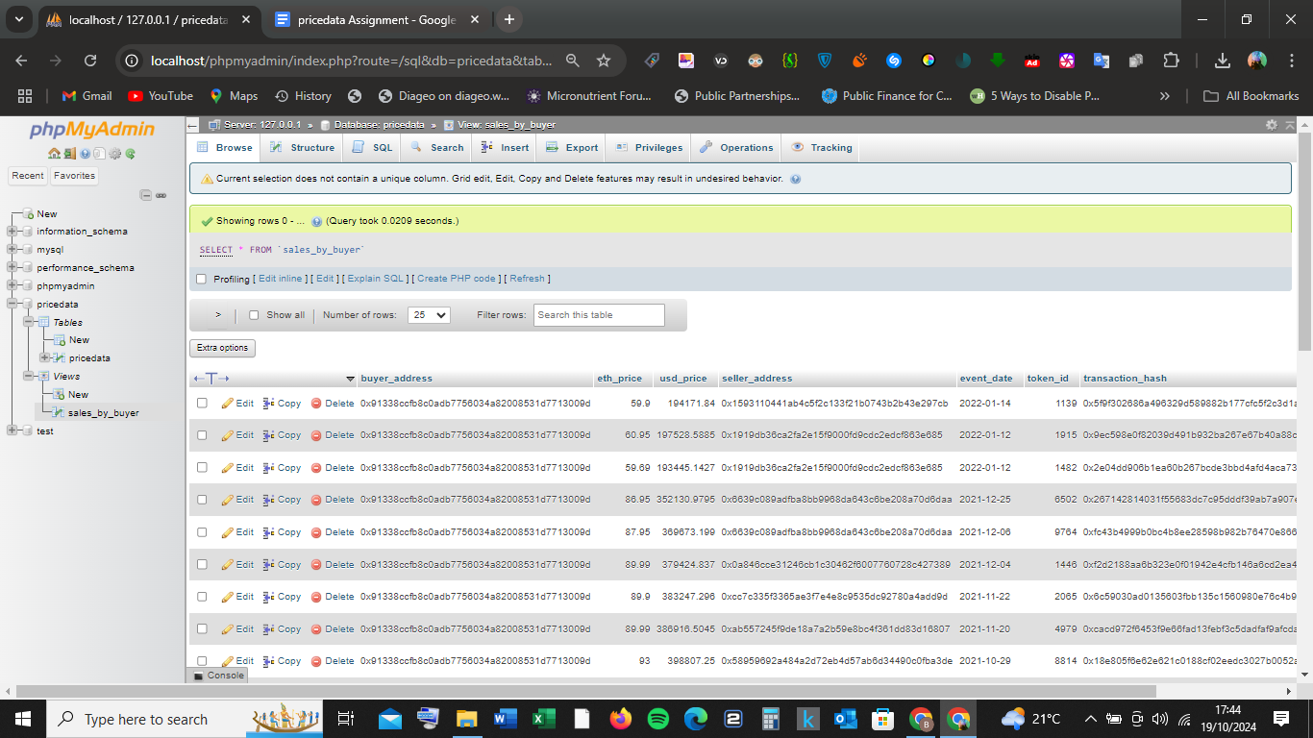

**8)Generate a histogram showing the range of ETH prices:** Since histograms are better visualized in tools like Google Sheets, you can generate the binning data in SQL and then move to Google Sheets for visualization.

**Sql Code:**

SELECT

FLOOR(eth_price / 10) * 10 AS price_range,

COUNT(*) AS count_in_range

FROM pricedata

GROUP BY price_range

ORDER BY price_range;

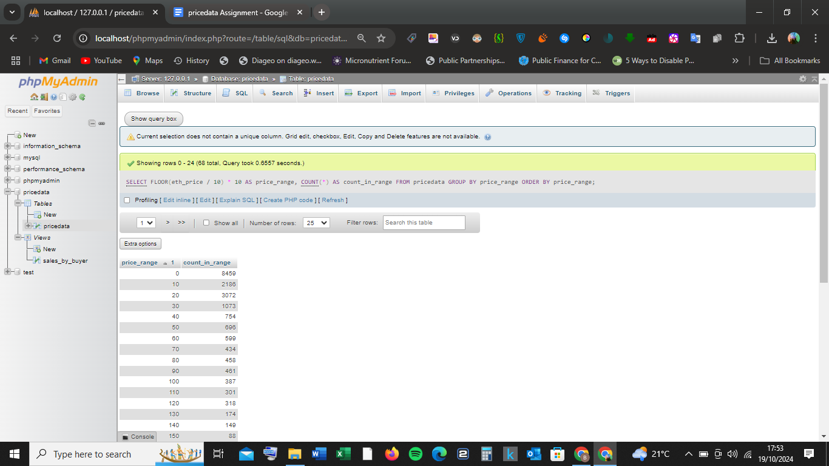

**ETH PRICE RANGE IN SPREADSHEET**

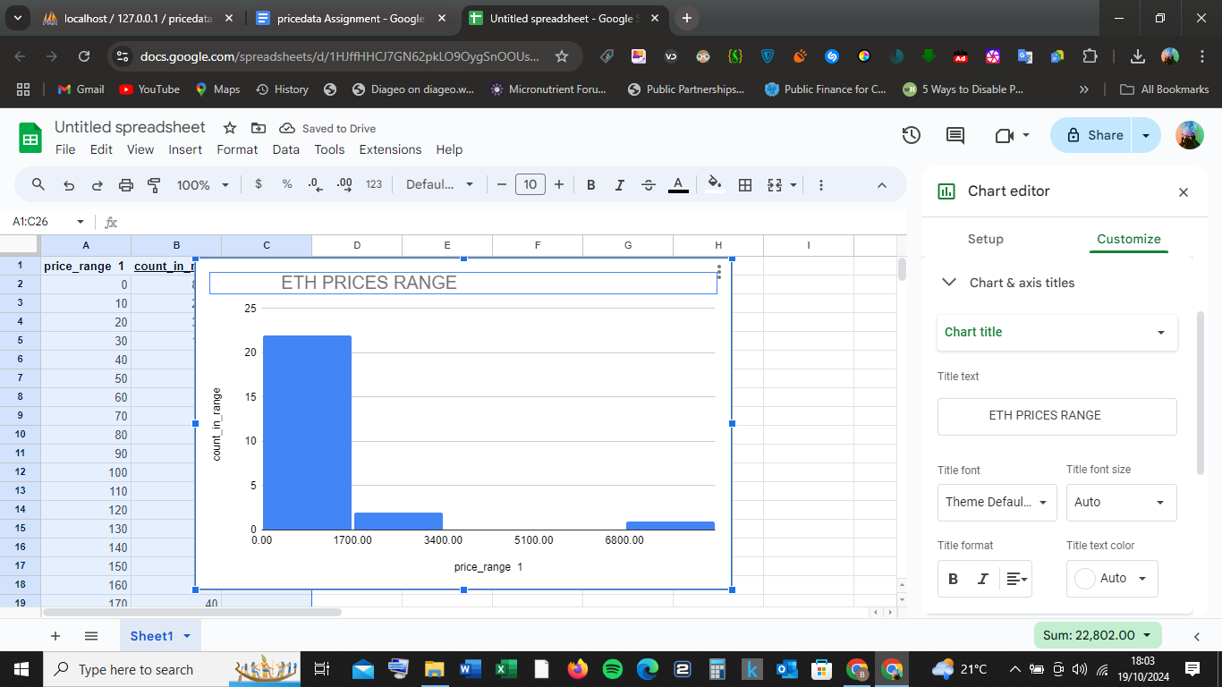

**ETH PRICE RANGE HISTOGRAM**



**9)Return a unioned query for the highest and lowest sale prices of each NFT:**

**Sql code:**

(SELECT name, MAX(usd_price) AS price, 'highest' AS type

FROM pricedata

GROUP BY name)

UNION

(SELECT name, MIN(usd_price) AS price, 'lowest' AS type

FROM pricedata

GROUP BY name);

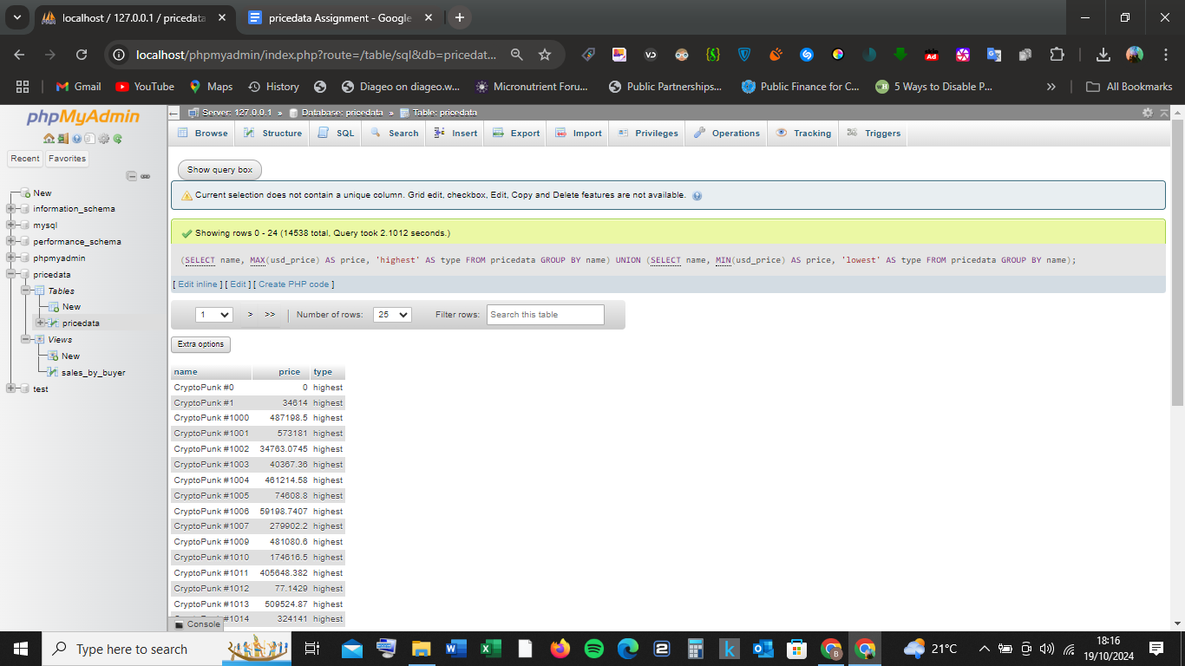

**Output:**

| [**name**](http://localhost/phpmyadmin/index.php?route=/sql&db=pricedata&table=pricedata&sql_query=%28SELECT+name%2C+MAX%28usd_price%29+AS+price%2C+%27highest%27+AS+type%0D%0AFROM+pricedata%0D%0AGROUP+BY+name%29%0D%0AUNION%0D%0A%28SELECT+name%2C+MIN%28usd_price%29+AS+price%2C+%27lowest%27+AS+type%0D%0AFROM+pricedata%0D%0AGROUP+BY+name%29++%0AORDER+BY+%60name%60+ASC&sql_signature=c37cfa24028cea670222f9340e98c23889879a7b9db76790d4d2241ff5f568cd&session_max_rows=25&is_browse_distinct=0) | [**price**](http://localhost/phpmyadmin/index.php?route=/sql&db=pricedata&table=pricedata&sql_query=%28SELECT+name%2C+MAX%28usd_price%29+AS+price%2C+%27highest%27+AS+type%0D%0AFROM+pricedata%0D%0AGROUP+BY+name%29%0D%0AUNION%0D%0A%28SELECT+name%2C+MIN%28usd_price%29+AS+price%2C+%27lowest%27+AS+type%0D%0AFROM+pricedata%0D%0AGROUP+BY+name%29++%0AORDER+BY+%60price%60+ASC&sql_signature=70b079bc99cfce6dc1676bce7c64b57279b1d22df5e65c8cfcf491a61ac82735&session_max_rows=25&is_browse_distinct=0) | [**type**](http://localhost/phpmyadmin/index.php?route=/sql&db=pricedata&table=pricedata&sql_query=%28SELECT+name%2C+MAX%28usd_price%29+AS+price%2C+%27highest%27+AS+type%0D%0AFROM+pricedata%0D%0AGROUP+BY+name%29%0D%0AUNION%0D%0A%28SELECT+name%2C+MIN%28usd_price%29+AS+price%2C+%27lowest%27+AS+type%0D%0AFROM+pricedata%0D%0AGROUP+BY+name%29++%0AORDER+BY+%60type%60+ASC&sql_signature=ef2c71200ea21396a5fca36c70687643da4c3a07d90cc56032dc694c29a6e3ce&session_max_rows=25&is_browse_distinct=0) |  |
| --- | --- | --- | --- |
| **CryptoPunk #0** | **0** | **highest** |  |
| **CryptoPunk #1** | **34614** | **highest** |  |
| **CryptoPunk #1000** | **487198.5** | **highest** |  |
| **CryptoPunk #1001** | **573181** | **highest** |  |
| **CryptoPunk #1002** | **34763.0745** | **highest** |  |
| **CryptoPunk #1003** | **40367.36** | **highest** |  |
| **CryptoPunk #1004** | **461214.58** | **highest** |  |

**10)Identify the top-selling NFT for each month/year combination:**

**Sql code:**

SELECT

DATE_FORMAT(event_date, '%Y-%m') AS month_year,

name,

SUM(usd_price) AS total_sales

FROM pricedata

GROUP BY month_year, name

ORDER BY total_sales DESC;

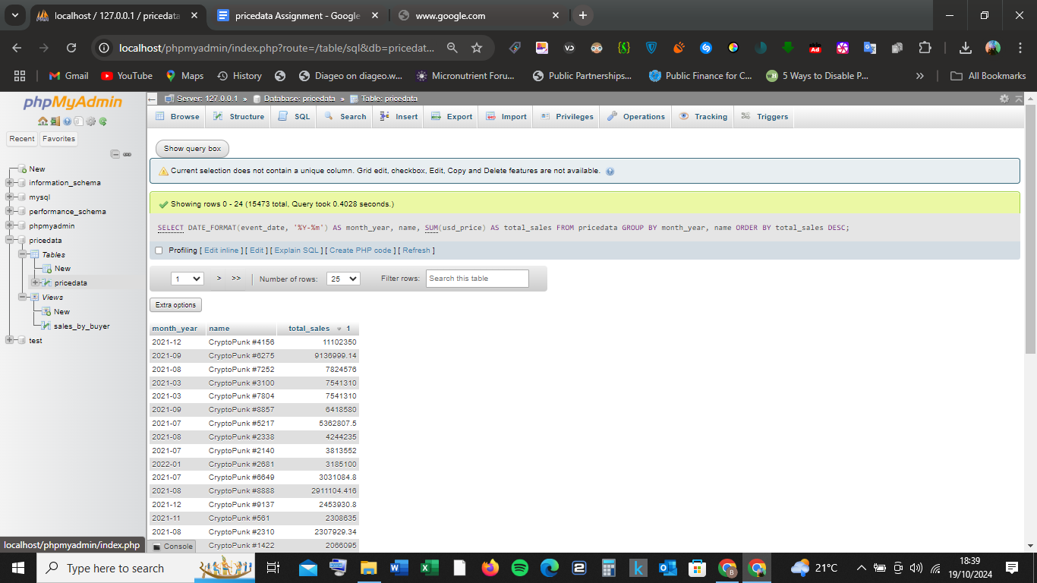

**Output:**

| [**month_year**](http://localhost/phpmyadmin/index.php?route=/sql&db=pricedata&table=pricedata&sql_query=SELECT+%0D%0A++++DATE_FORMAT%28event_date%2C+%27%25Y-%25m%27%29+AS+month_year%2C+%0D%0A++++name%2C+%0D%0A++++SUM%28usd_price%29+AS+total_sales%0D%0AFROM+pricedata%0D%0AGROUP+BY+month_year%2C+name++%0AORDER+BY+%60month_year%60+ASC&sql_signature=a18a9e7a68f67fa00f842204e735e8885bd27090efda25c47399df052868b918&session_max_rows=25&is_browse_distinct=0) | [**name**](http://localhost/phpmyadmin/index.php?route=/sql&db=pricedata&table=pricedata&sql_query=SELECT+%0D%0A++++DATE_FORMAT%28event_date%2C+%27%25Y-%25m%27%29+AS+month_year%2C+%0D%0A++++name%2C+%0D%0A++++SUM%28usd_price%29+AS+total_sales%0D%0AFROM+pricedata%0D%0AGROUP+BY+month_year%2C+name++%0AORDER+BY+%60pricedata%60.%60name%60+ASC&sql_signature=5bfdb1b83d522359f9dd4430f4d3b2658659b47f2163ab138e91e508394aed8f&session_max_rows=25&is_browse_distinct=0) | [**total_sales Descending 1**](http://localhost/phpmyadmin/index.php?route=/sql&db=pricedata&table=pricedata&sql_query=SELECT+%0D%0A++++DATE_FORMAT%28event_date%2C+%27%25Y-%25m%27%29+AS+month_year%2C+%0D%0A++++name%2C+%0D%0A++++SUM%28usd_price%29+AS+total_sales%0D%0AFROM+pricedata%0D%0AGROUP+BY+month_year%2C+name++%0AORDER+BY+%60total_sales%60+ASC&sql_signature=a108a0a3f39d40ffbf1703ad6669d1d55dabdcd1cb190d5fcbbcb5f86fd9c3b5&session_max_rows=25&is_browse_distinct=0) |  |
| --- | --- | --- | --- |
| **2021-12** | **CryptoPunk #4156** | **11102350** |  |
| **2021-09** | **CryptoPunk #6275** | **9136999.14** |  |
| **2021-08** | **CryptoPunk #7252** | **7824576** |  |
| **2021-03** | **CryptoPunk #3100** | **7541310** |  |
| **2021-03** | **CryptoPunk #7804** | **7541310** |  |
| **2021-09** | **CryptoPunk #8857** | **6418580** |  |

**11)Calculate the total volume of sales on a monthly basis:**

**Sql code:**

SELECT

DATE_FORMAT(event_date, '%Y-%m') AS month_year,

SUM(usd_price) AS total_volume

FROM pricedata

GROUP BY month_year

ORDER BY month_year;

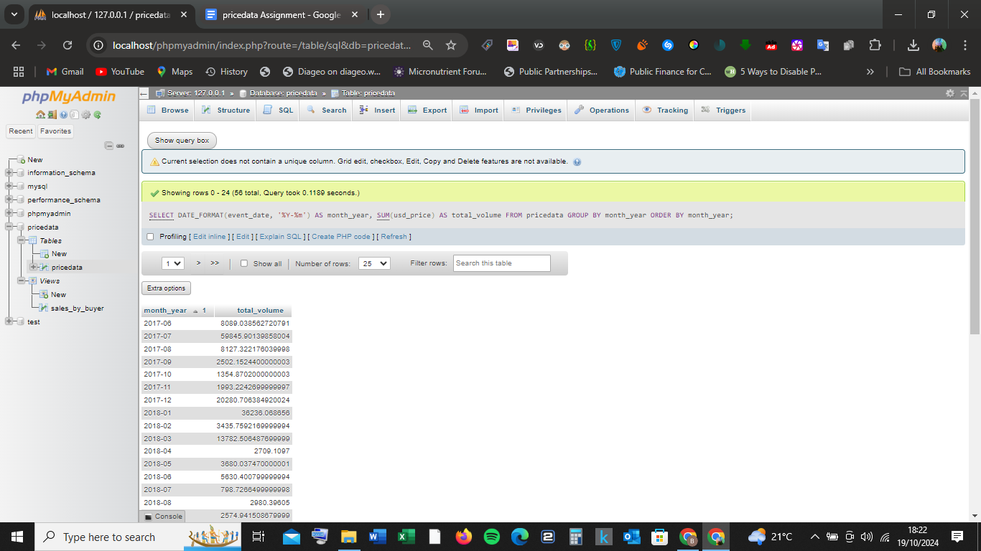

**Output(A few):**

| [**month_year Ascending 1**](http://localhost/phpmyadmin/index.php?route=/sql&db=pricedata&table=pricedata&sql_query=SELECT+%0D%0A++++DATE_FORMAT%28event_date%2C+%27%25Y-%25m%27%29+AS+month_year%2C+%0D%0A++++SUM%28usd_price%29+AS+total_volume%0D%0AFROM+pricedata%0D%0AGROUP+BY+month_year++%0AORDER+BY+%60month_year%60+DESC&sql_signature=05618dd8582d947715fd867909149f776e7932244cc5bf170698398021b955c2&session_max_rows=25&is_browse_distinct=0) | [**total_volume**](http://localhost/phpmyadmin/index.php?route=/sql&db=pricedata&table=pricedata&sql_query=SELECT+%0D%0A++++DATE_FORMAT%28event_date%2C+%27%25Y-%25m%27%29+AS+month_year%2C+%0D%0A++++SUM%28usd_price%29+AS+total_volume%0D%0AFROM+pricedata%0D%0AGROUP+BY+month_year++%0AORDER+BY+%60total_volume%60+ASC&sql_signature=219bf32325e8ea1bf00aea5a3deb7b5dac77528a6a4393f4af6815679b3081c5&session_max_rows=25&is_browse_distinct=0) |  |
| --- | --- | --- |
| **2017-06** | **8089.038562720791** |  |
| **2017-07** | **59845.90139858004** |  |
| **2017-08** | **8127.322176039998** |  |
| **2017-09** | **2502.1524400000003** |  |
| **2017-10** | **1354.8702000000003** |  |

**12)Count how many transactions a specific wallet address made:**

**Sql Code:**

SELECT COUNT(*) AS total_transactions

FROM pricedata

WHERE buyer_address = '0x91338ccfb8c0adb7756034a82008531d7713009d';

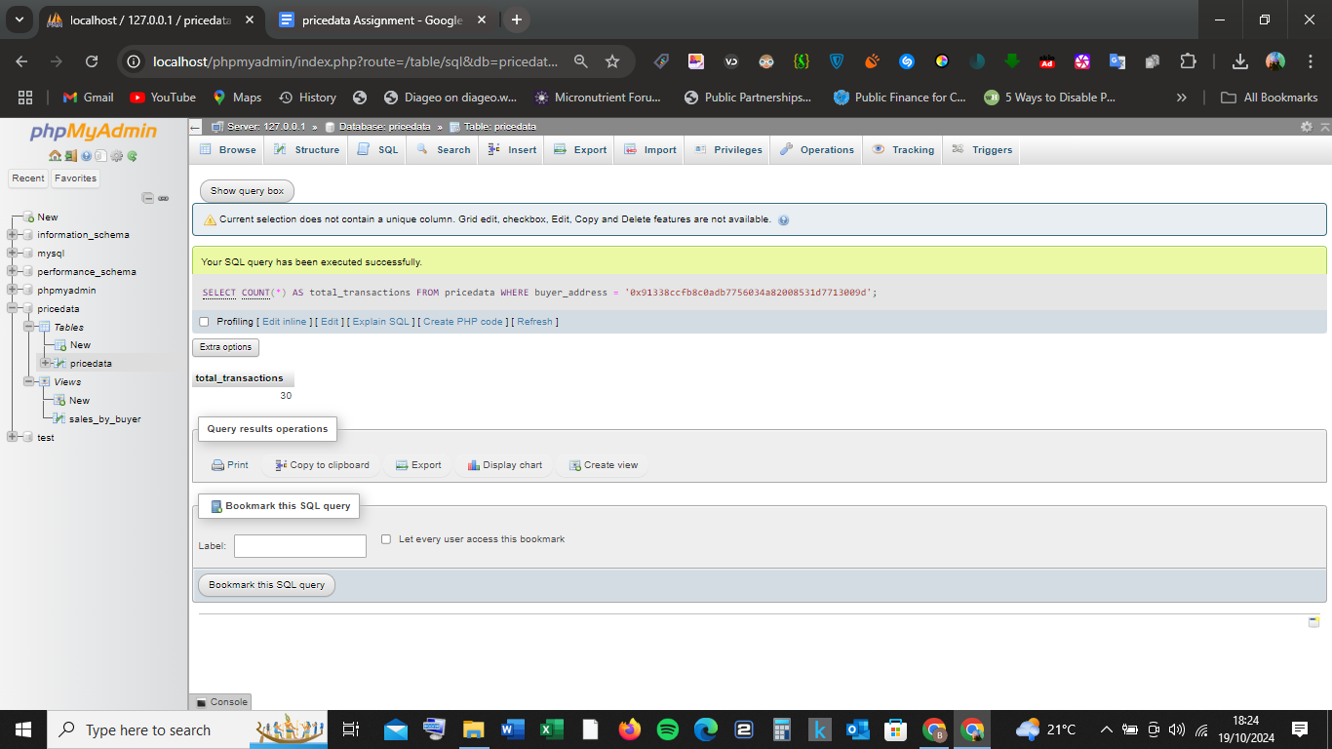

**Output:**

total_transactions

30

**13)Create a daily estimated average value calculator (excluding outlier sales below 10% of the daily average price)**

**Sql Code:**

SELECT

event_date,

AVG(usd_price) AS daily_avg

FROM

pricedata

GROUP BY

event_date

HAVING

daily_avg > (0.10 * (SELECT AVG(usd_price) FROM pricedata))

LIMIT 0, 25;

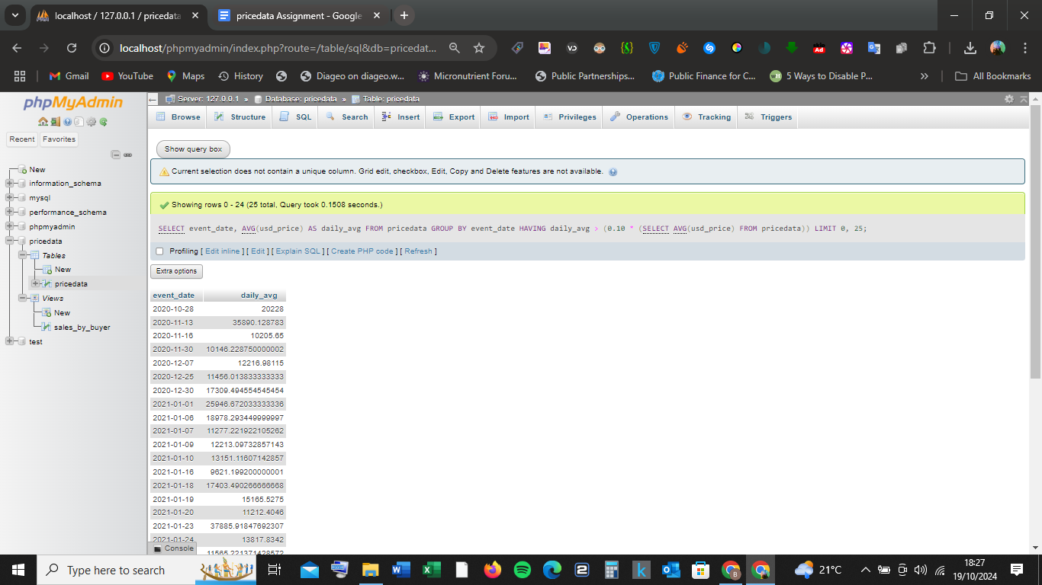

**Output(A few):**

| [**event_date**](http://localhost/phpmyadmin/index.php?route=/sql&db=pricedata&table=pricedata&sql_query=SELECT+%0D%0A++++event_date%2C+%0D%0A++++AVG%28usd_price%29+AS+daily_avg%0D%0AFROM+%0D%0A++++pricedata%0D%0AGROUP+BY+%0D%0A++++event_date%0D%0AHAVING+%0D%0A++++daily_avg+%3E+%280.10+%2A+%28SELECT+AVG%28usd_price%29+FROM+pricedata%29%29+%0AORDER+BY+%60pricedata%60.%60event_date%60+ASC+LIMIT+0%2C+25&sql_signature=7b8f42ff1be6e7f9d8d33f12ce972e3ea8767a6adf158554a1e100f195db8fc5&session_max_rows=25&is_browse_distinct=0) | [**daily_avg**](http://localhost/phpmyadmin/index.php?route=/sql&db=pricedata&table=pricedata&sql_query=SELECT+%0D%0A++++event_date%2C+%0D%0A++++AVG%28usd_price%29+AS+daily_avg%0D%0AFROM+%0D%0A++++pricedata%0D%0AGROUP+BY+%0D%0A++++event_date%0D%0AHAVING+%0D%0A++++daily_avg+%3E+%280.10+%2A+%28SELECT+AVG%28usd_price%29+FROM+pricedata%29%29+%0AORDER+BY+%60daily_avg%60+ASC+LIMIT+0%2C+25&sql_signature=9a2d3d71c7a92a5d160ebbb680175311ee0e73f3742f7ed96a976c5967045f9a&session_max_rows=25&is_browse_distinct=0) |  |
| --- | --- | --- |
| **2020-10-28** | **20228** |  |
| **2020-11-13** | **35890.128783** |  |
| **2020-11-16** | **10205.65** |  |
| **2020-11-30** | **10146.228750000002** |  |
| **2020-12-07** | **12216.98115** |  |
| **2020-12-25** | **11456.013833333333** |  |
| **2020-12-30** | **17309.494554545454** |  |